Standard Operating Procedure - Invoicing Solutions - Brilliance v1.0

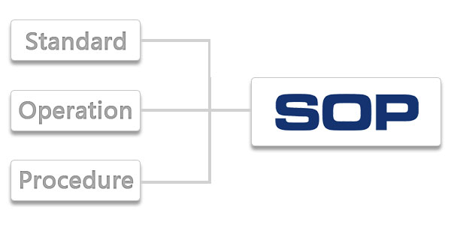

General Process Document
Ver 1.0

Table of Contents
I. VERSION CONTROL AND SIGNOFFS 3
i) POLICY AUTHORITY & APPROVAL 3
ii) SOP CHANGE MANAGEMENT PROCESS 3
II. MODULE – Invoicing Solutions - Brilliance v1.0
4
i) OBJECTIVE 4
ii) PROCESS OVERVIEW 4
iii) ACRONMYS 4
iv) KEY DEFEINITIONS 4
v) SYSTEMS AND APPLICATIONS 5
vi) SIPOC 5
III. PROCESS MAP 6
IV. DESKTOP PROCEDURE 6
i) STEP BY STEP PROCESS 6
ii) SCOPE DETAILS 6
iii) BUSINESS RULES 6
V. EXCEPTION HANDLING 7
VI. COMPLANCE AND CONTROLS 7
VII. ESCALATION MATRIX 7

VERSION CONTROL AND SIGNOFFS

Document Revision History
Version | Status | Comment | Prepared By | Date | Verified By | Approved By
1.0 | Drafted |  | Dhanasekaran | 30th March 2022 | Prem Kumar

Document Sign off (SGS)
Version | Name | Position | Date | Signature
1.0 | Rohit Jayaprakash | Supervisor
1.0 | Arun Balasubramanian | Manager

Document Sign off(Client)
Version | Name | Position | Date | Signature

POLICY AUTHORITY & APPROVAL

Any changes or amendments to Policy must be approved by the Policy Owner(s)

Stakeholders must be given an opportunity to provide feedback on any suggested changes or amendments to a policy.

Exceptions to this policy are subject to approval by the following nominated authority:

Policy Owner(s)-Dhanasekaran, Prem Kumar, Rohit Jayaprakash, Arun Balasubramanian

SOP CHANGE MANAGEMENT PROCESS

SOP will be reviewed in case of any major changes/modifications either due to client inputs or due to any workflow changes/modifications from SGS or once in six months whichever is earlier. The year under consideration would be calendar year.

MODULE – INVOICING SOLUTION-BRILLIANCE

OBJECTIVE

The objective of this record is to document the as-is process Of Invoicing Solution Brilliance followed by Sutherland team.

PROCESS OVERVIEW

- Open the G drive application through G mail.
- Open file titled Brilliance Publishing (BPI)
- Download the document and save the document in excel file
- Open SAP and log on
- Export a copy tom excel
- Match the title and amount from Brilliance

ACRONMYS

Sr. No. | Abbreviation/Acronyms | Description
1 | BPI | Brilliance Publishing

KEY DEFEINITIONS

Sr. No. | Term | Definitions
1 | FBL5N | SAP Code

SYSTEMS AND APPLICATIONS

Sr. No. | Application | Description
1 | SAP | To match the Invoices
2

SIPOC

Process or Function Name: Account summary Brilliance |  | Date: 30th March 2022
Scope: Creating and matching the Invoices | Notes: This process frequency is 15th day of the month and EOM also

SUPPLIER | INPUT | PROCESS | OUTPUT | CUSTOMERS
Who supplies the process in-puts? | What inputs are required? | What are the major steps in the process? | What is the process out-puts? | Who receives the outputs?
Google drive application through G mail | Excel document file and SAP | - Open the G drive application through G mail.  - Open file titled Brilliance Publishing (BPI)  - Download the document and save the document in excel file  - Open SAP and log on  - Export a copy to excel  - Match the title and amount from Brilliance and the amount SAP | BPI Document summary | Customers

PROCESS MAP

DESKTOP PROCEDURE

STEP BY STEP PROCESS

Output Type/Print Schedule:
- Transactional / Custom
- Print Frequency – 004 – Semi Monthly (15th & EOM)

Account Overview:
- Book Billing through the COMN feed to WCSS
- Invoices are keyed by billers into a Google Document that contain additional details required on invoice by the customer

Invoice Process:
PERFORM THIS PROCESS ON THE 15TH DAY OF THE MONTH AND THE LAST DAY OF EACH MONTH
- Open the Google Drive Application through Gmail

- Open File titled Brilliance Publishing (BPI)
  - https://docs.google.com/spreadsheets/d/15QwjhwLHxNwF9hr32MoEyql6Dx82WsqjJ8BmbSpqZeg/edit#gid=0
  - At the top left Select File → Download as → Microsoft Excel (.xlsx)
  - When the downloaded excel file opens save as:
    - Filename: Brilliance Publishing DWLD MM-DD-YY
    - Location: S:\WCSS Accounts Info & Procedures\Brilliance Publishing (BPI)\Google Doc Downloads

- Open SAP and logon
  - Enter FBL5N in the Command Field and hit enter on the keyboard
  - Enter the SAP# 1826923 Customer Account field and hit the F8 key on the keyboard to run the report
Note: As per Cheryl advice Amazon brilliance(Digital lizard) invoice mail received Cfs Chennai invoicing mail box please invoice included Brilliance summary excel file.
  - Export a copy to Excel 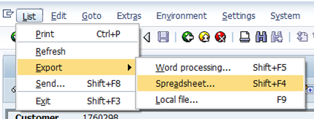
  - Remove/delete any invoice lines with the text indicating the invoice was included on a prior Brilliance Publishing Summary
  - Essentially, delete any lines with text that do not show a Book Title.

- Match the Title & Amount from the Brilliance Publishing DWLD file to the Text & Amount from the SAP report
  - If there is a match enter the Assignment number from the SAP export into the Brilliance Publishing DWLD file in the blank cell of the same row in column A.

- Once everything possible is matched up, re-save the Brilliance Publishing DWLD file

- Open the Brilliance Publishing (BPI) Summary Template
  - Location: S:\WCSS Accounts Info & Procedures\Brilliance Publishing (BPI)
  - Any lines from the Brilliance Publishing DWLD file that contain invoice numbers need to be copied into the Brilliance Publishing (BPI) Summary Template.
  - Once pasted into the Brilliance Summary Template, highlight column F, right click and go to Format Cells. Choose the Custom Category and in the Type Field enter 13 zeros. Then click ok.
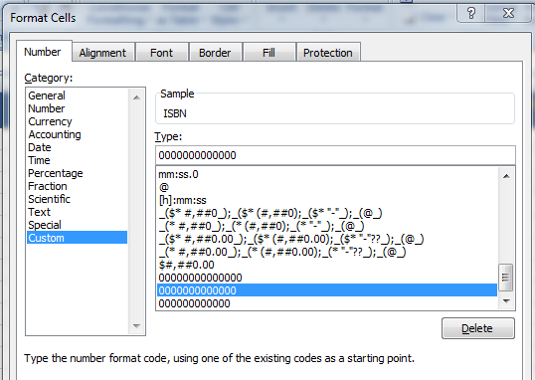
  - Once finished, save the template as:
    - Filename: Brilliance Publishing (BPI) Summary MM-DD-YY
    - Location: S:\WCSS Accounts Info & Procedures\Brilliance Publishing (BPI)\2014 Summaries

- Go back to the Brilliance Publishing (BPI) google document and remove any lines that are included on the saved Brilliance Publishing (BPI) Summary. If a line was not found in SAP leave it on the google doc for next time.

- Send the file to the customer:
TO: elaineb@amazon.com, ACCOUNTS_PAYABLE@brillianceaudio.com, michatem@amazon.com, Gifford@brilliancepublishing.com,
CC: charles.gilbert@lsccom.com, tom.zachary@lsccom.com, pamela.g.young@lsccom.com, rose.m.pomerantz@lsccom.com , cashapplications@lsccom.com
Subject: Brilliance Publishing (BPI) Summary Invoice MMDDYYYY
Just attach the summary file and send
- Update SAP
  - Update the text notes for each invoice listed on the summary file to read
    - Brilliance Publishing (BPI) Summary MM-DD-YY Initials

SCOPE DETAILS

List of activities and sub process in scope & out of scope with respect to the process

Sr. No. | In Scope | Out of Scope
1 | Open file title Brilliance Publishing
2 | Export a copy to Excel
3 | Matching the Invoice

BUSINESS RULES

- Open file titled Brilliance Publishing (BPI)
- Download the document and save the document in excel file
- Open SAP and log on
- Export a copy tom excel
- Match the title and amount from Brilliance

EXCEPTION HANDLING

Exceptions with respect to activities being performed in this process

COMPLANCE AND CONTROLS

Critical Success Factors | Key Performance Indicators (KPIs)
Potential Data Integrity Issues
Business Risks | Key Controls Related to Business Risk

ESCALATION MATRIX

Sr. No. | Issue raised by | Action required by | Timeline
1 | Thomas Zachary | Invoice Solutions Team
2 | Charles Gilbert | Invoice Solutions Team
3 | Pamela Young | Invoice Solutions Team
4 | Rose Pomerantz | Invoice Solutions Team

